Intel RealSense – Spatial Awareness Wearable

What is the project about?

This project is about augmenting the senses of the visually impaired to make them aware of their surroundings and allow them to explore what is around them.

How this works?

This project uses a Depth Camera (Intel RealSense R200) to see how far the objects in its field of view are. The field of view of the camera is divided into 8 sections, 3 top (right, center, left), 3 middle (right, center, left) and 2 bottom (right, left).

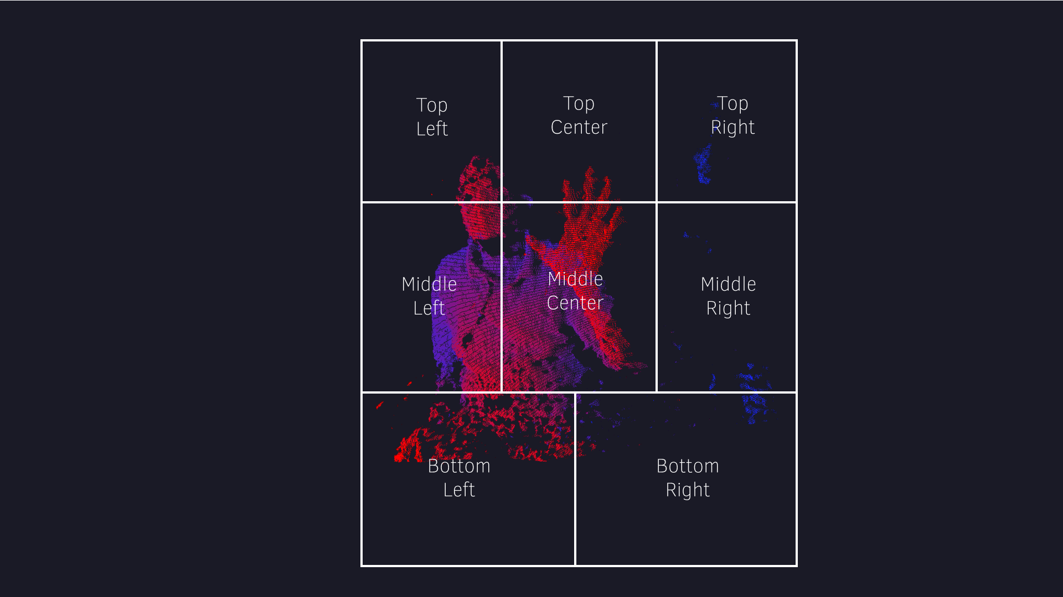

We find the closest depth pixel in these 8 Sections and track it. The closest depth pixel is the point detected by the camera on the nearest object in that section. Based on the distance of the closest depth pixel in its particular section, we map it to vibration actuators on the body. Closer the object is that particular section, stronger is the vibration, and vice-a-versa. The vibration actuators are placed on 8 parts of the body, 3 on chest (left chest, center chest, and right chest), 3 on hip level (left hip, belly, right hip), and two on legs (left leg and right leg)

The vibration actuator is a vibration motor connected to battery powered WiFi enabled microcontroller (Particle Core). The 8 Sections in the field of view of the camera are mapped to the 8 vibration actuators. The Vibration Actuators communicate with the laptop with the R200 camera over TCP using a portable router.

The laptop, and the 8 vibration actuators are assigned fixed IP addresses in the portable router. The Laptop runs an application which processes the depth data from the camera and functions as a TCP Server to handle the communication with the vibration actuators. The vibration actuators run TCP Client application which connect to the server application with a specific IP address and port number. Based on the fixed IP addresses the Server application knows which Vibration Actuator is for which body part.

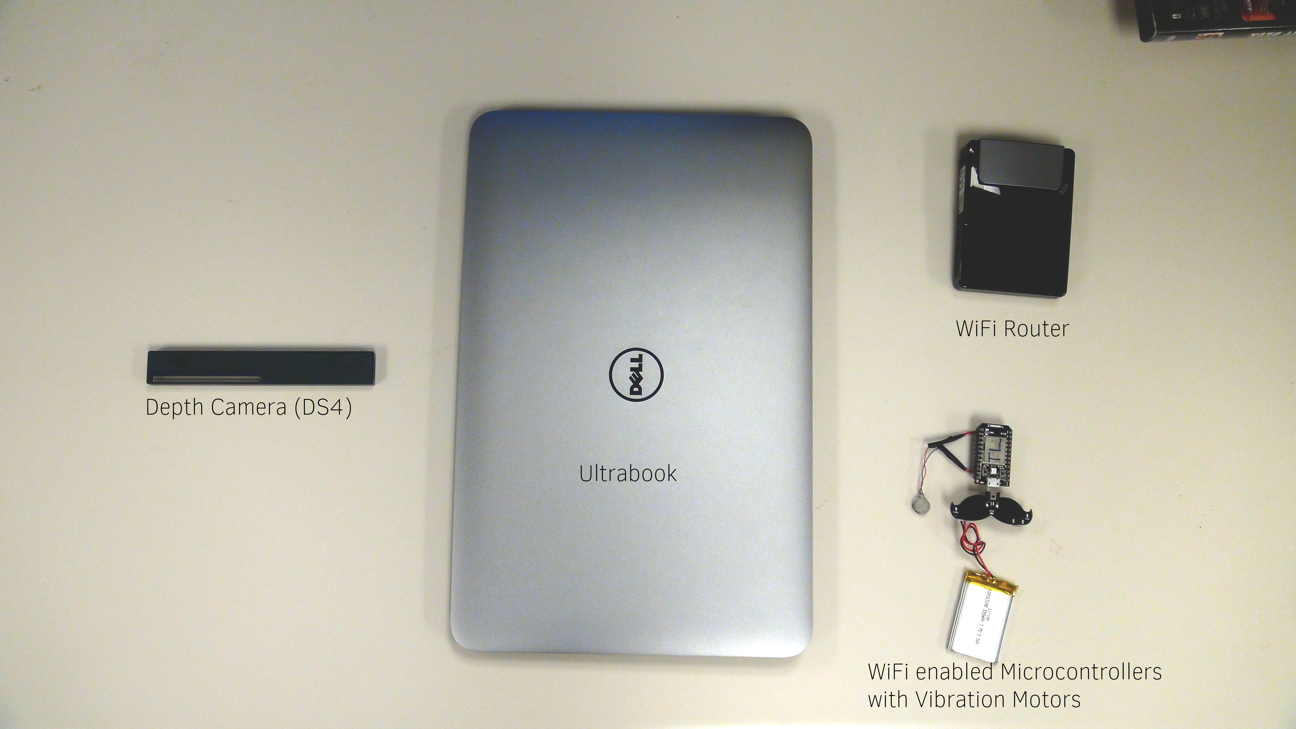

Parts list

1. X86 based Laptop with USB 3.0 support.
2. [Intel RealSense R200 camera](http://click.intel.com/intel-realsense-developer-kit-r200.html)
3. [Portable router](http://www.amazon.com/D-Link-Systems-Portable-Charger-DIR-510L/dp/B00HGLOQ24/ref=sr_1_1?ie=UTF8&qid=1431465967&sr=8-1&keywords=d-link+dir-510l)
4. [Particle Core/photon](https://store.particle.io/)
5. [Vibration Motors](https://www.sparkfun.com/products/8449)
6. [Lipo batteries](https://www.sparkfun.com/products/341)
7. [Micro Lipo charger](http://www.adafruit.com/product/1904)
8. Latching Switch
9. Wires for connection

Diagrams and tech diagrams

Circuit diagrams

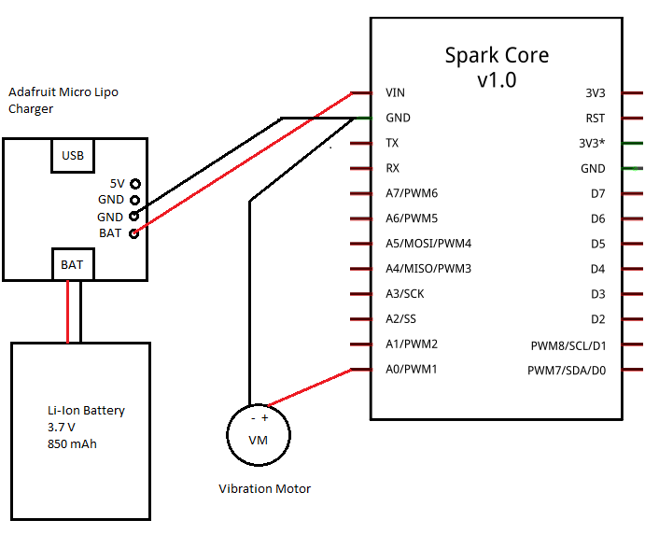

Vibration Actuator

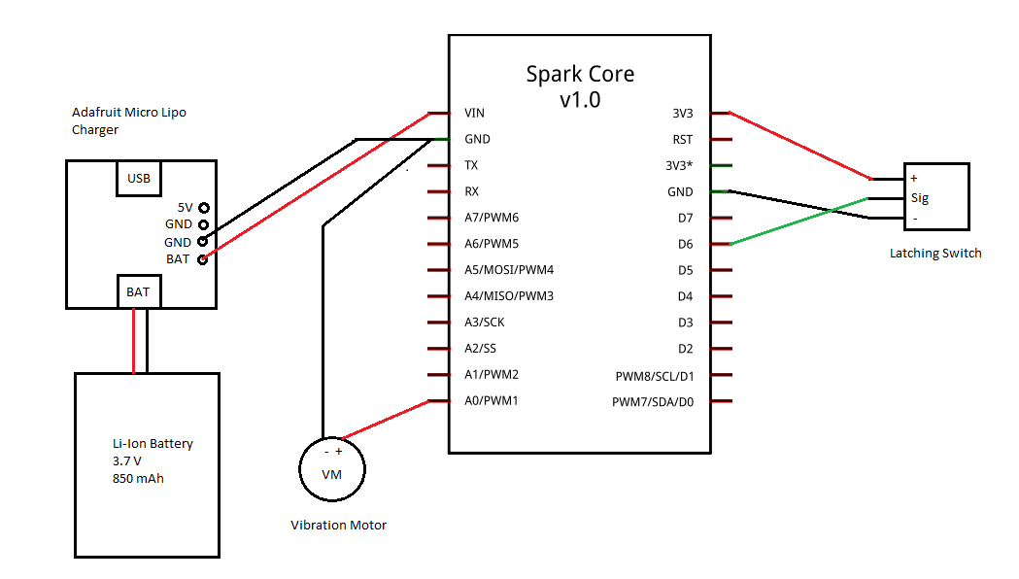

Vibration Actuator with button